STATE TRANSITION DIAGRAM FOR
ASHISH KUMAR DALAI-23SCSE1012454
SECTION -29

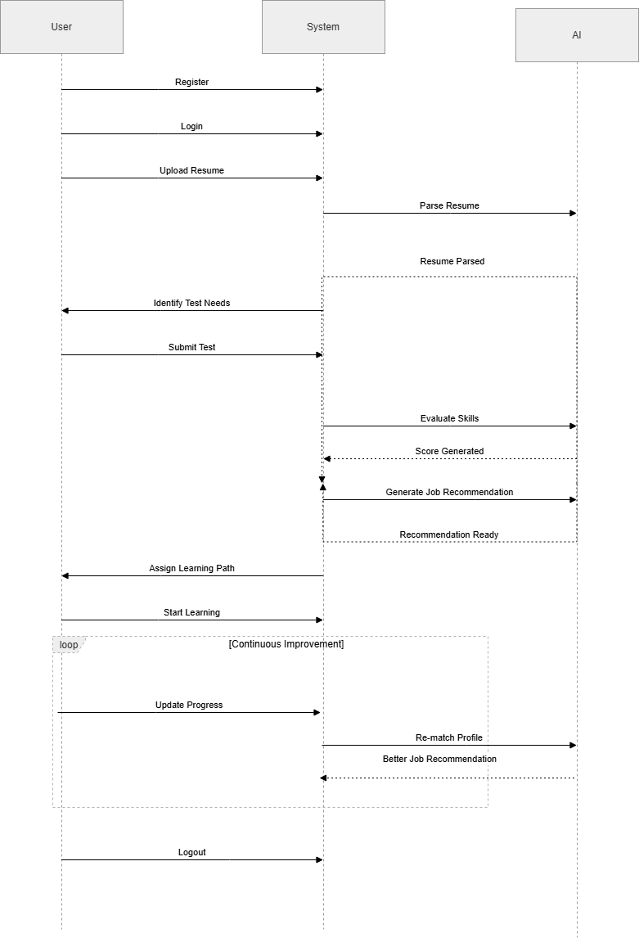
THE AI-DRIVEN JOB RECOMMENDATION AND SKILL ASSESSMENT PLATFORM

